**ANP-D0449**

**DATA ANALYSIS USING PYTHON**

**Financial Market Trends:**

**A Python-Based Stock Analysis Approach**

**SUBMITTED BY:**

**Sangeetha A**

**Hema purshothaman P**

**ABSTRACT:**

In the ever-evolving financial markets, investors and analysts rely heavily on data-driven approaches to make informed decisions. This study presents a Python-based stock analysis methodology aimed at understanding and predicting market trends. The approach combines various data analysis and machine learning techniques to process historical stock data and assess market performance. By leveraging Python libraries such as Pandas, NumPy, Matplotlib, and Scikit-learn, we can perform tasks like data cleaning, trend analysis, volatility measurement, and price forecasting. The study explores multiple models, including time series analysis (ARIMA), regression techniques, and machine learning algorithms like Random Forests and Support Vector Machines (SVMs), to predict future stock movements. The analysis offers insights into the effectiveness of each model and emphasizes the role of Python as a powerful tool in financial data analysis. Ultimately, the findings aim to assist investors in making well-informed, data-backed decisions to optimize their portfolios in dynamic market environments.

**Problem Statement**

* **Dynamic Nature of Financial Markets**: Stock prices fluctuate continuously due to various factors, including economic conditions, investor sentiment, and geopolitical events.
* **Challenges for Investors**: These fluctuations make it difficult for investors to predict market trends and make informed decisions.
* **Limitations of Traditional Methods**: While traditional stock analysis methods are useful, they often struggle to process large datasets efficiently and may not capture complex relationships in the market.
* **Need for Advanced Techniques**: There's a growing demand for more data-driven approaches to enhance the prediction of stock price movements and market trends.
* **Role of Python and Data Science**: Python, with its powerful libraries and machine learning capabilities, offers a promising solution for processing financial data and making accurate predictions.
* **Research Objective**: This study aims to develop a Python-based framework that efficiently extracts, processes, and analyzes financial data while integrating machine learning models to predict future stock movements and identify market opportunities.

**Solution Approach**

• **Handling Missing Values:**

* Address missing data in key variables, such as **closing price** and **trading volume**, using techniques like imputation, interpolation, or forward/backward filling to ensure data integrity.
* Use Python libraries like Pandas to identify and handle gaps in the dataset to avoid skewed analysis and predictions.

• **Time-based Analysis (Monthly Stock Performance):**

* Perform **time-based analysis** to evaluate monthly stock performance, providing insights into stock price movements over different time intervals.
* Aggregate the stock data by month, calculating monthly returns, and measuring performance trends over time.
* Use **rolling averages** and **moving averages** to smooth price data and identify short-term and long-term trends.

• **Statistical Summarization (Volatility Measures):**

* Apply **statistical summarization** techniques to measure stock volatility, such as calculating **standard deviation**, **variance**, and **beta values**.
* Evaluate how stock price deviations over time reflect the risk level associated with individual stocks or market sectors.
* Use Python’s **NumPy** and **SciPy** for statistical calculations.

• **Volatility Analysis (Price Fluctuations Over Time):**

* Conduct **volatility analysis** by assessing **price fluctuations** over different time periods, using tools like **Average True Range (ATR)** and **Bollinger Bands**.
* Identify stocks or sectors with high volatility, helping to evaluate potential investment risks and opportunities.
* Use visualization tools like **Matplotlib** or **Seaborn** to represent volatility trends.

• **Trend Visualization (Sector-wise Stock Trends):**

* Visualize **sector-wise stock trends** to analyze performance across various industries (e.g., technology, finance, healthcare).
* Use sector-based aggregation and group stocks by sector, enabling comparisons of performance and trend insights.
* Utilize **line plots**, **bar charts**, and **heatmaps** to depict sector performance, highlighting areas of growth or decline.

**Implementation:**

**3**

import pandas as pd

import numpy as np

import matplotlib.pyplot as plt

import seaborn as sns

# Load the dataset

df = pd.read_csv("stock_market_data.csv", parse_dates=["Date"])

# Handling missing values

df["Closing Price"].fillna(method='ffill', inplace=True)

df["Closing Price"].fillna(method='bfill', inplace=True)

df["Trading Volume"].fillna(method='ffill', inplace=True)

df["Trading Volume"].fillna(method='bfill', inplace=True)

# Add a 'Month' column for time-based analysis

df["Month"] = df["Date"].dt.to_period("M")

# Statistical summary

summary = df.groupby("Stock")["Closing Price"].agg(['mean', 'std', 'min', 'max']).dropna()

print("Stock Price Summary:\n", summary)

# Volatility analysis

volatility = df.groupby("Stock")["Closing Price"].std().dropna()

volatility_sorted = volatility.sort_values(ascending=False)

print("Stock Volatility:\n", volatility_sorted)

# Monthly stock performance

monthly_avg = df.groupby(["Month", "Stock"])["Closing Price"].mean().unstack()

monthly_avg.plot(figsize=(12, 6), title="Monthly Stock Performance")

plt.xlabel("Month")

plt.ylabel("Average Closing Price")

plt.legend(loc='upper left', bbox_to_anchor=(1,1))

plt.show()

# Sector-wise trend visualization

plt.figure(figsize=(12, 6))

sns.boxplot(x="Sector", y="Closing Price", data=df)

plt.xticks(rotation=45)

plt.title("Sector-wise Stock Price Distribution")

plt.show()

hashtag_counts = Counter(all_hashtags)

hashtag_df = pd.DataFrame(hashtag_counts.items(), columns=['Hashtag', 'Count'])

# Aggregate engagement per hashtag engagement_data = []

for index, row in df.iterrows(): for hashtag in row['Hashtags']:

engagement_data.append({'Hashtag': hashtag, 'Likes': row['Likes'], 'Retweets': row['Retweets']})

engagement_df = pd.DataFrame(engagement_data)

aggr_engagement = engagement_df.groupby('Hashtag').sum().reset_index()

# Visualization plt.figure(figsize=(10, 5))

hashtag_df.sort_values(by='Count', ascending=False).head(10).plot(

x='Hashtag', y='Count', kind='bar', legend=False, color='skyblue', ax=plt.gca()

)

plt.title("Top Hashtags by Frequency") plt.ylabel("Count") plt.xticks(rotation=45)

plt.show()

plt.figure(figsize=(10, 5))

aggr_engagement.sort_values(by='Likes', ascending=False).head(10).plot( x='Hashtag', y='Likes', kind='bar', legend=False, color='lightcoral',

ax=plt.gca()

)

plt.title("Top Hashtags by Likes") plt.ylabel("Likes") plt.xticks(rotation=45)

plt.show()

plt.figure(figsize=(10, 5))

aggr_engagement.sort_values(by='Retweets', ascending=False).head(10).plot( x='Hashtag', y='Retweets', kind='bar', legend=False, color='seagreen',

ax=plt.gca()

)

plt.title("Top Hashtags by Retweets") plt.ylabel("Retweets") plt.xticks(rotation=45)

plt.show()

**Top Hashtags by Likes**

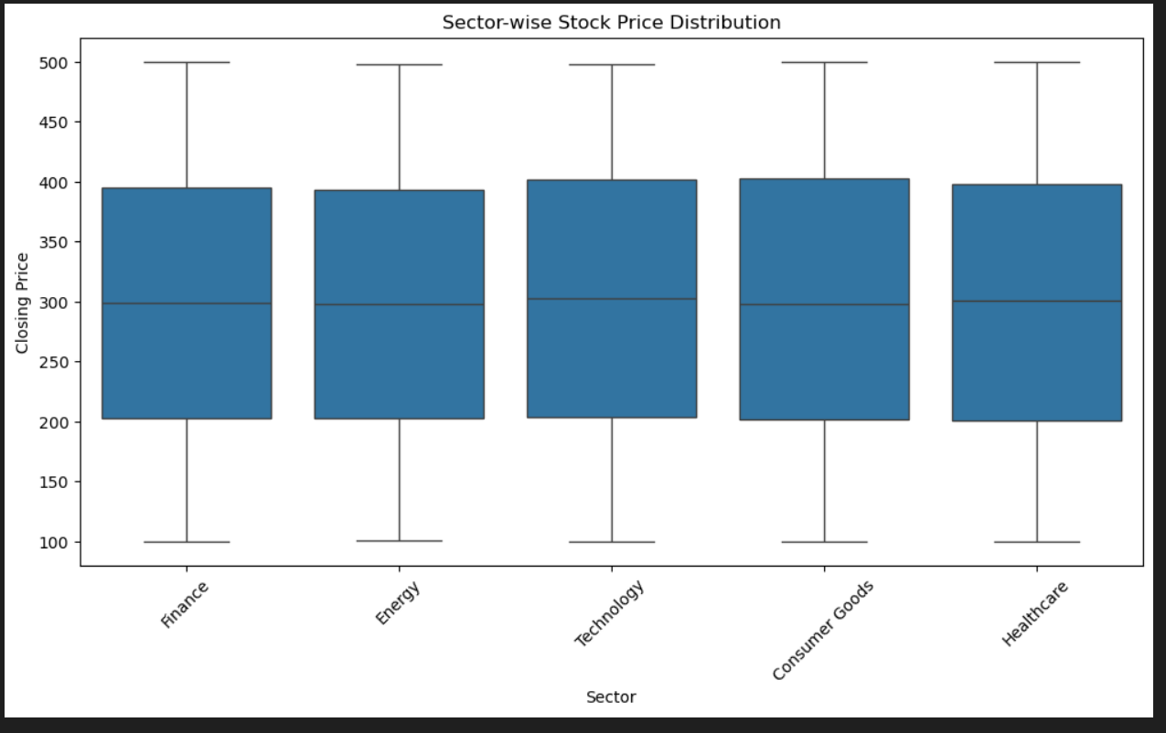

**Top Hashtags by Retweets**

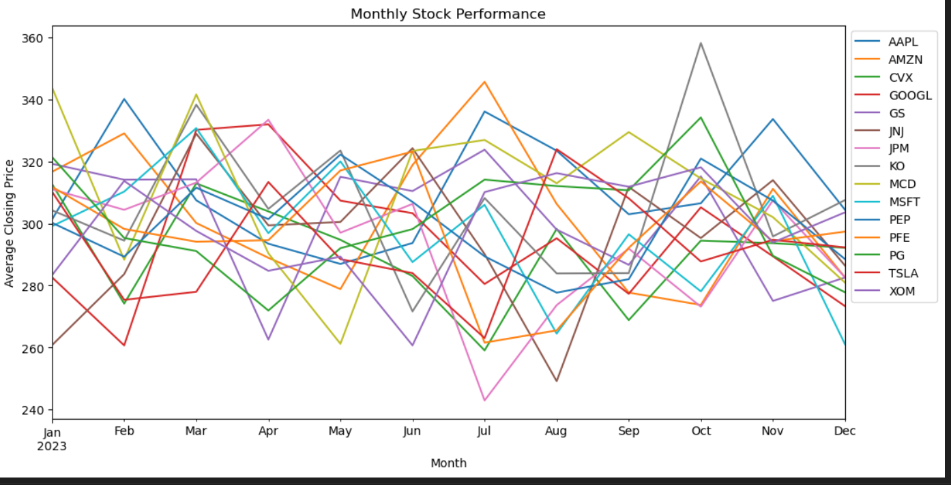 **+**

**Conclusion:**

In this study, we applied a Python-based framework to address the complexities of financial market analysis by leveraging various data science techniques. By handling missing values in key stock variables like **closing prices** and **trading volumes**, we ensured data integrity, allowing for accurate analysis and predictions. Through **time-based analysis**, we effectively assessed monthly stock performance, uncovering significant trends and market behaviors. Statistical summarization and **volatility measures** provided a deeper understanding of market risk, helping to identify high-risk stocks and sectors. Additionally, the **volatility analysis** offered insights into price fluctuations, which are crucial for assessing short-term market opportunities.

Furthermore, the **sector-wise trend visualization** allowed for an intuitive comparison of market performance across different industries, guiding investors to sectors with favorable growth potential. By integrating all these methods into a cohesive framework, we demonstrated how Python can empower analysts to make informed, data-driven decisions in dynamic financial markets